Aim: To install MS SQL Server and perform data management operations using SQL Server Management Studio (SSMS).

Theory:
Q1. What is MS SQL Server?
Microsoft SQL Server is a relational database management system (RDBMS) developed by Microsoft. It is used to store, retrieve, and manage data efficiently using Structured Query Language (SQL) and T-SQL (Transact-SQL — Microsoft's extension). It supports features like transaction processing, business intelligence, analytics, and high availability.

Q2. What is SSMS and what are its features?
SQL Server Management Studio (SSMS) is a free integrated graphical environment for managing, configuring, and administering any SQL Server infrastructure.
- Object Explorer – Browse databases, tables, views, stored procedures, etc.
- Query Editor – Write, execute, and debug T-SQL queries with syntax highlighting and IntelliSense.
- Backup & restore – Perform and schedule database backups.
- Security management – Manage logins, users, roles, and permissions.
- Import/Export Wizard – Move data between SQL Server and other formats (Excel, CSV, etc.).

Q3. What is the difference between Left Join, Right Join, and Full Join?
Join Type | Description
LEFT JOIN (or LEFT OUTER JOIN) | Returns all rows from the left table, and matching rows from the right table. If no match, right table columns are NULL.
RIGHT JOIN (or RIGHT OUTER JOIN) | Returns all rows from the right table, and matching rows from the left table. If no match, left table columns are NULL.
FULL JOIN (or FULL OUTER JOIN) | Returns all rows from both tables. Matches where possible; NULL in columns from the table lacking a match.

Q4. Write the basic SQL queries for SELECT, INSERT, UPDATE, and DELETE operations with examples.
Assume a table called Students with columns: StudentID, Name, Age, and Major.

- SELECT is used to retrieve data from a database.
Example 1: SELECT * FROM Students; – This gets all columns and all rows from the Students table.
Example 2: SELECT Name, Age FROM Students WHERE Major = 'Computer Science'; – This gets only the Name and Age columns for students whose Major is Computer Science.

- INSERT is used to add new rows to a table.
Example 1: INSERT INTO Students (StudentID, Name, Age, Major) VALUES (1, 'Alice Johnson', 20, 'Biology'); – This inserts a single student with specified values for selected columns.
Example 2: INSERT INTO Students VALUES (2, 'Bob Smith', 22, 'Mathematics'); – This inserts a new row by providing values for all columns in the order they appear in the table.

- UPDATE is used to modify existing data in a table.
Example 1: UPDATE Students SET Major = 'Physics' WHERE Name = 'Bob Smith'; – This changes Bob Smith's major to Physics.
Example 2: UPDATE Students SET Age = 21, Major = 'Computer Science' WHERE StudentID = 1; – This updates both Age and Major for the student with StudentID 1.

- DELETE is used to remove rows from a table.
Example 1: DELETE FROM Students WHERE StudentID = 2; – This deletes only the student with StudentID 2.
Example 2: DELETE FROM Students WHERE Age > 25; – This deletes all students older than 25. Example 3: DELETE FROM Students; – This deletes all rows from the Students table (use with caution).

Q5. What are the steps to create a database and a table in SSMS?
There are two methods: using the graphical interface or using T-SQL queries.

Method 1: Using the GUI (no coding):
First, open SSMS and connect to your SQL Server instance.
To create a database, right-click on the Databases folder in Object Explorer, then select "New Database."
Enter a name for your database, such as UniversityDB. You can optionally set file paths, initial size, and autogrowth settings. Click OK to create the database.
To create a table, expand your newly created database in Object Explorer. Right-click on the Tables folder, then select "New" and then "Table."
A design grid will appear where you define your columns.
For each column, enter a Column Name (e.g., StudentID, Name, Age, Major), choose a Data Type (e.g., int, nvarchar(50), int, nvarchar(50)), and specify whether Allow Nulls is checked. To set a primary key, right-click on the StudentID row and choose "Set Primary Key."
After defining all columns, save the table by pressing Ctrl+S and give it a name like Students. The table will appear under the Tables folder.

Method 2: Using T-SQL Query Editor:
Open a new query window in SSMS by clicking "New Query." Then type and execute the following commands:
CREATE DATABASE UniversityDB;
GO
USE UniversityDB;
GO
CREATE TABLE Students (
StudentID INT PRIMARY KEY,
Name NVARCHAR(50) NOT NULL,
Age INT,
Major NVARCHAR(50)
);
GO

Q6. Perform the following using MS SQL Server and SSMS:
Install SQL Server and SSMS
Create a database named DMBI_LAB
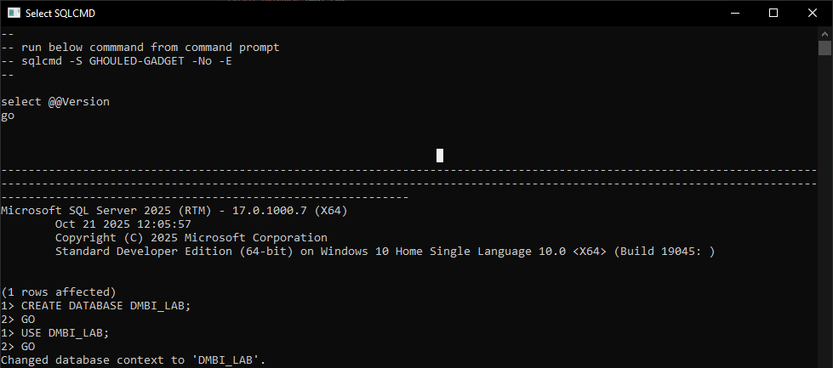
Create two tables — Student (ID, Name, Age, Gender, Branch) and Teacher (ID, Name, Branch)
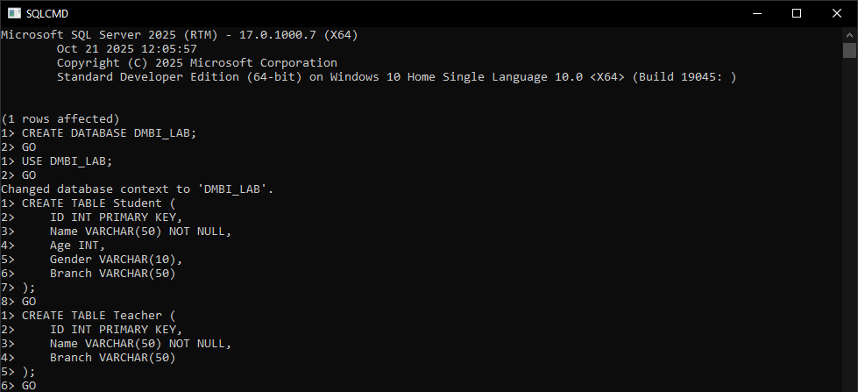
Insert data into both tables
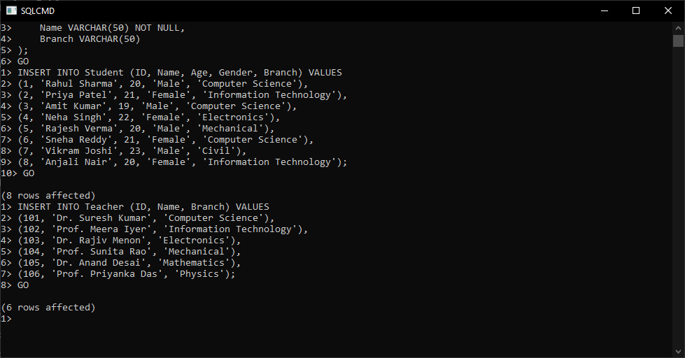

View data in the tables
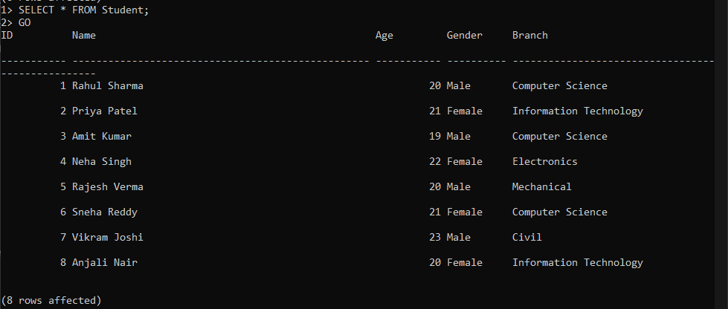

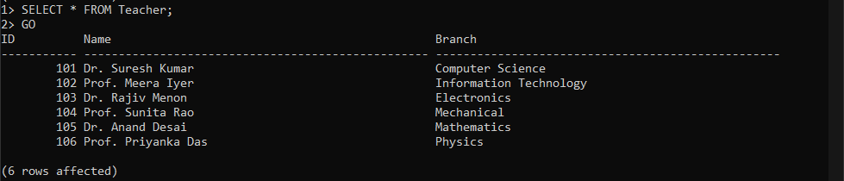

Perform Left Join, Right Join, and Full Join on the two tables
Left join:
SELECT
s.ID AS 'Student ID',
s.Name AS 'Student Name',
s.Age,
s.Gender,
s.Branch AS 'Student Branch',
ISNULL(CAST(t.ID AS VARCHAR), 'No Teacher') AS 'Teacher ID',
ISNULL(t.Name, 'Not Assigned') AS 'Teacher Name',
ISNULL(t.Branch, 'N/A') AS 'Teacher Branch'
FROM
Student s
LEFT JOIN
Teacher t ON s.Branch = t.Branch
ORDER BY
s.ID;
GO

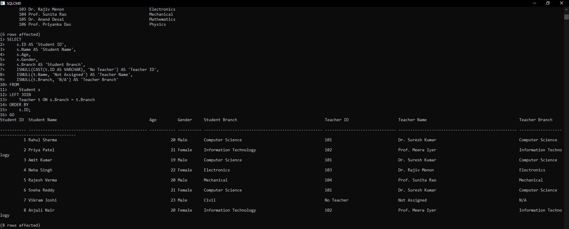

Right join:
SELECT
ISNULL(CAST(s.ID AS VARCHAR), 'No Student') AS 'Student ID',
ISNULL(s.Name, 'Not Enrolled') AS 'Student Name',
ISNULL(s.Branch, 'N/A') AS 'Student Branch',
t.ID AS 'Teacher ID',
t.Name AS 'Teacher Name',
t.Branch AS 'Teacher Branch'
FROM
Student s
RIGHT JOIN
Teacher t ON s.Branch = t.Branch
ORDER BY
t.ID;
GO
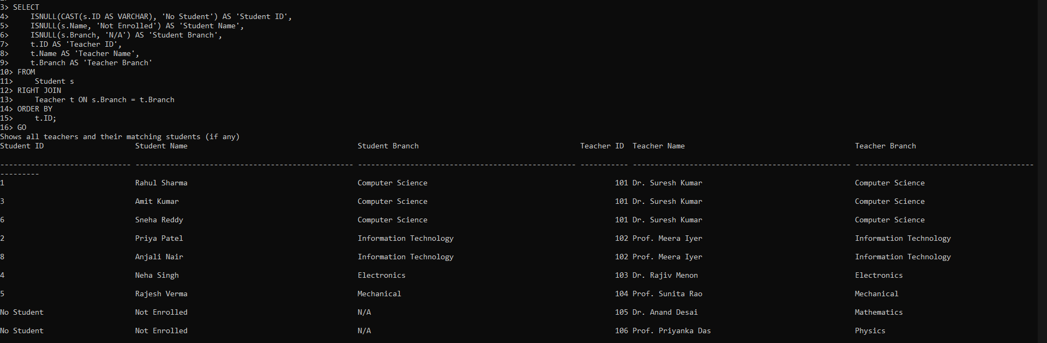
Full join:
SELECT
s.ID AS 'Student ID',
s.Name AS 'Student Name',
s.Branch AS 'Student Branch',
t.ID AS 'Teacher ID',
t.Name AS 'Teacher Name',
t.Branch AS 'Teacher Branch',
CASE
WHEN s.ID IS NOT NULL AND t.ID IS NOT NULL THEN 'Matched'
WHEN s.ID IS NOT NULL AND t.ID IS NULL THEN 'No Teacher Assigned'
ELSE 'No Students Enrolled'
END AS 'Status'
FROM
Student s
FULL JOIN
Teacher t ON s.Branch = t.Branch
ORDER BY
ISNULL(s.ID, 999), ISNULL(t.ID, 999);
GO

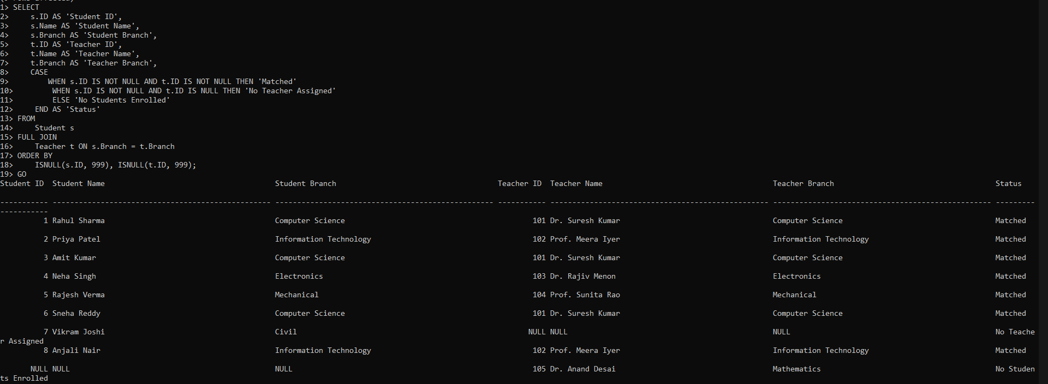
Conclusion:
Successfully installed MS SQL Server and perform data management operations using SQL Server Management Studio (SSMS).

